

BIT4139 Ethical Hacking and Counter Measures

BSCCS/2024/62210 EVANS MUTHOMI KABURU

Tool of choice-Nmap

Contents
Week 1-3 work 4
Installing of Nmap 4
User Interface 4
Version check 5
Version Check on the UI 6
OS scan 6
OS scan on the GUI 7
Narrowed down OS Scan 8
Aggressive Scans 9
Aggressive scan on GUI 9
Host scanning 10
Scanning Multiple hosts 11
Scanning multiple hosts on CMD 12
Port scanning 12
Port scan on CMD 13
TCP port scan 13
Scanning a range of TCP ports 13
Scanning top 5 ports in my DNS 14
Week 4 15
Task 1 15
Domain info 15
Domain registrar (chase.com) 17
IP address (chase.com) 17
Email patterns 18
Task 2 19
Port scanning (chase.com) 19
Detection of the running services (pentest-ground.com) 19
OS scan 20
Web Technology Enumeration (pentest-ground.com) 20

Week 1-3 work

Installing of Nmap

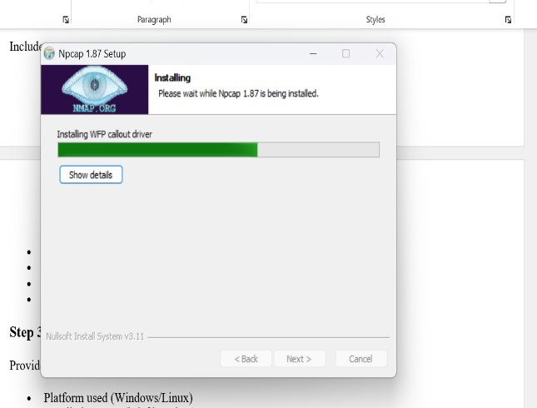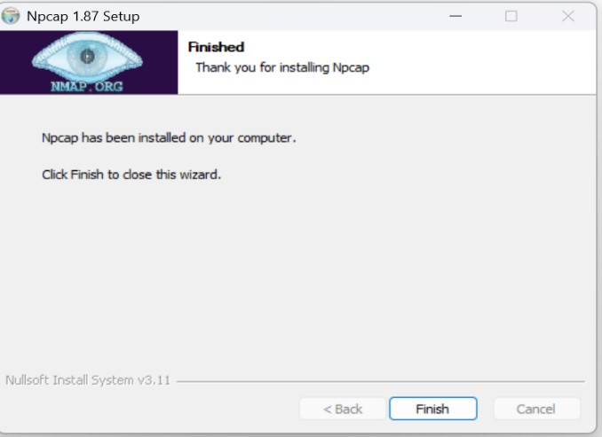

User Interface
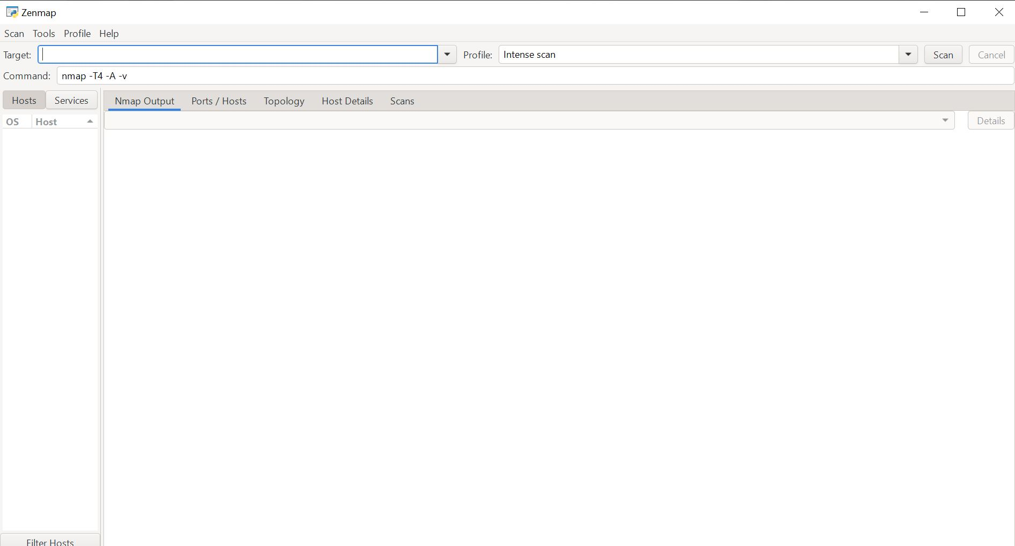

Version check
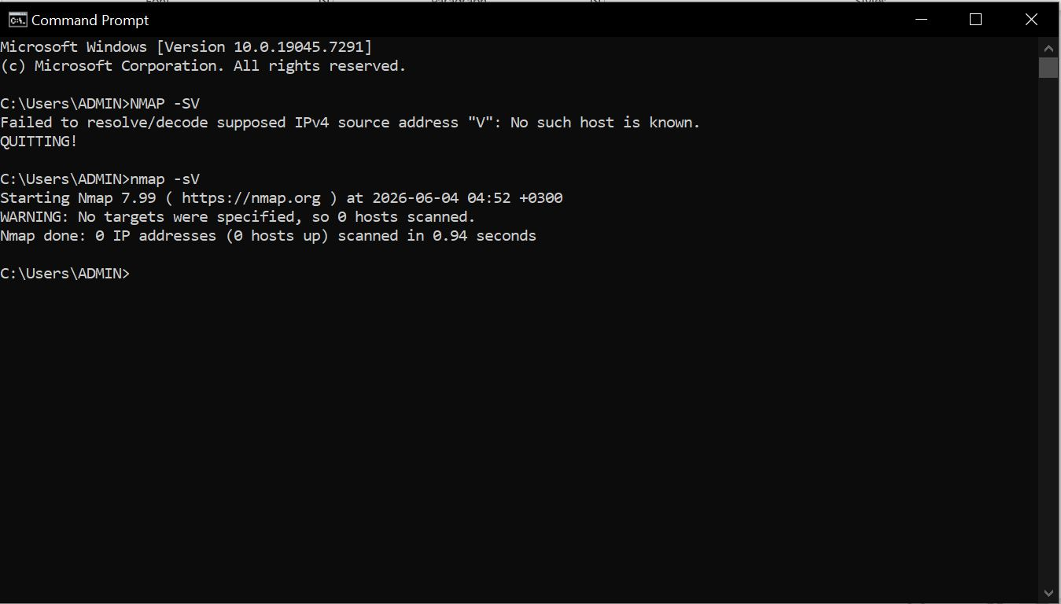

Version Check on the UI
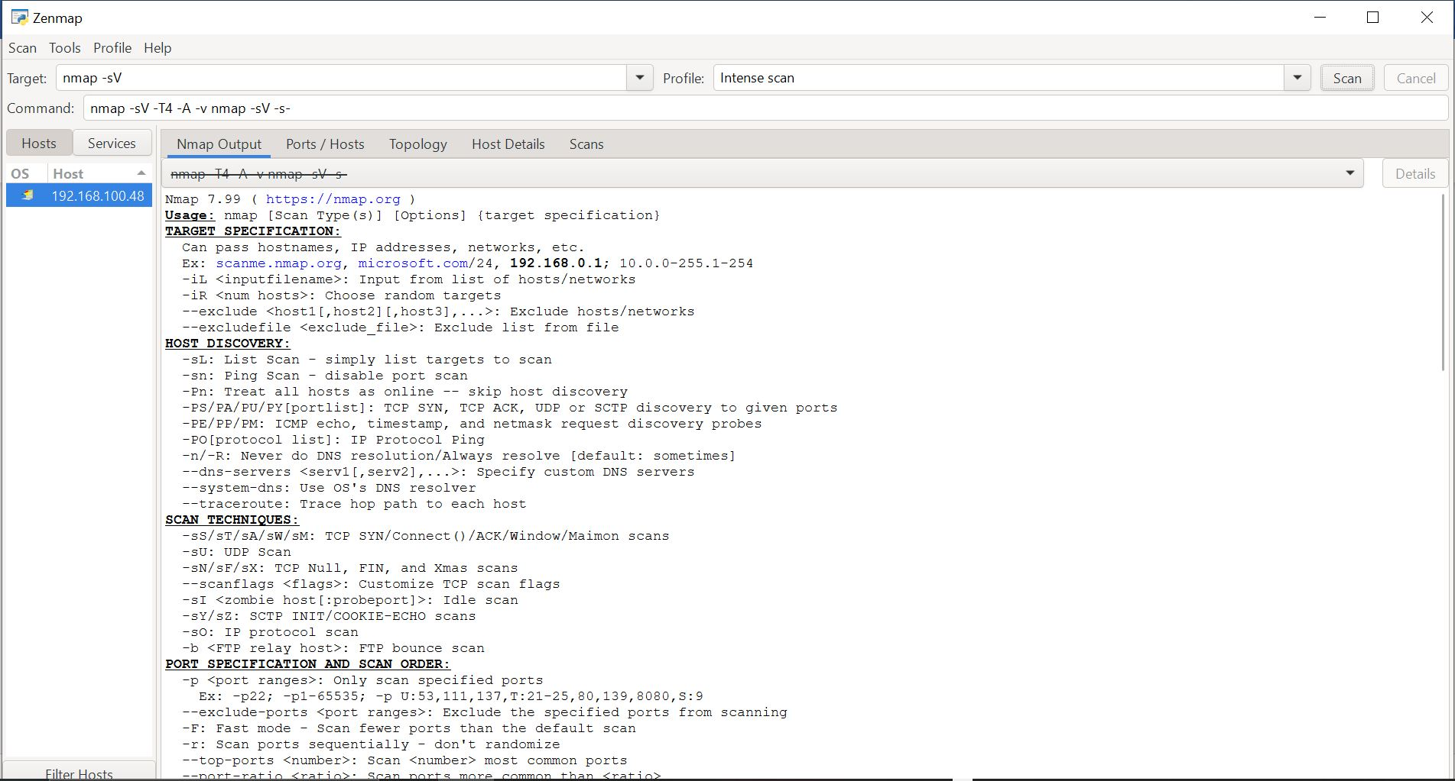

OS scan
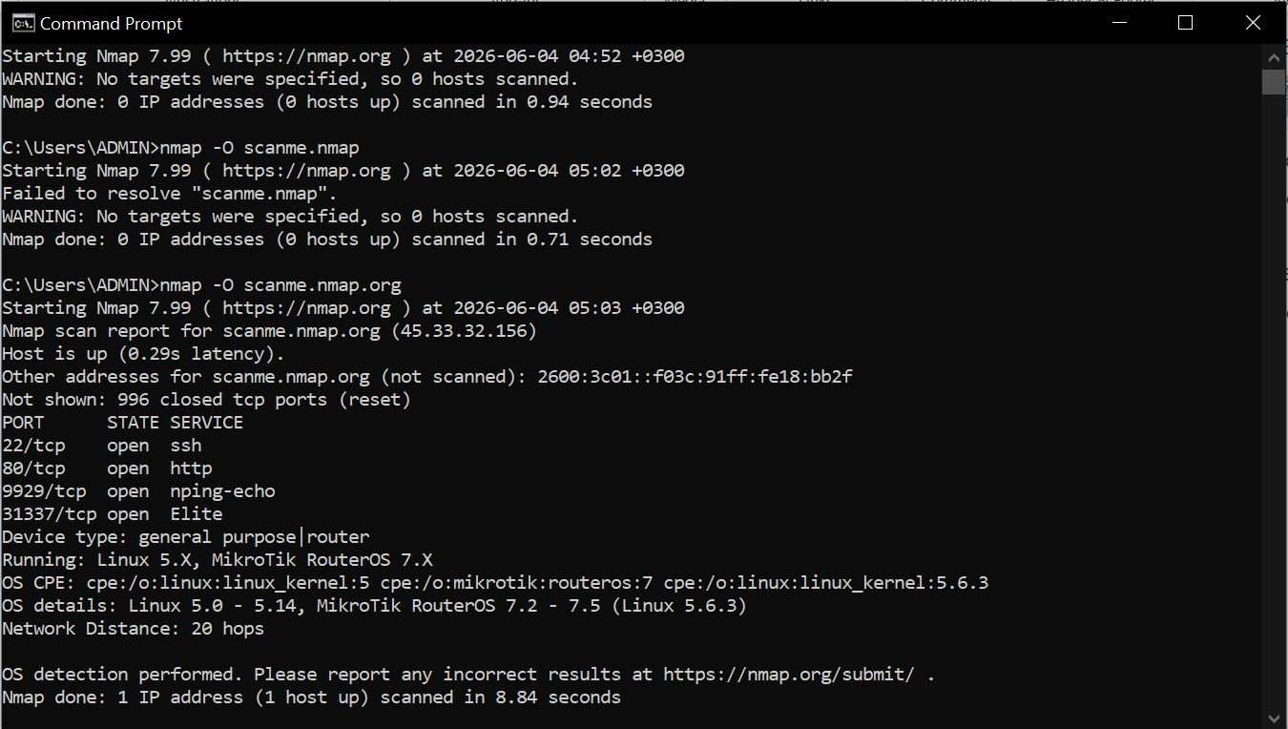

OS scan on the GUI
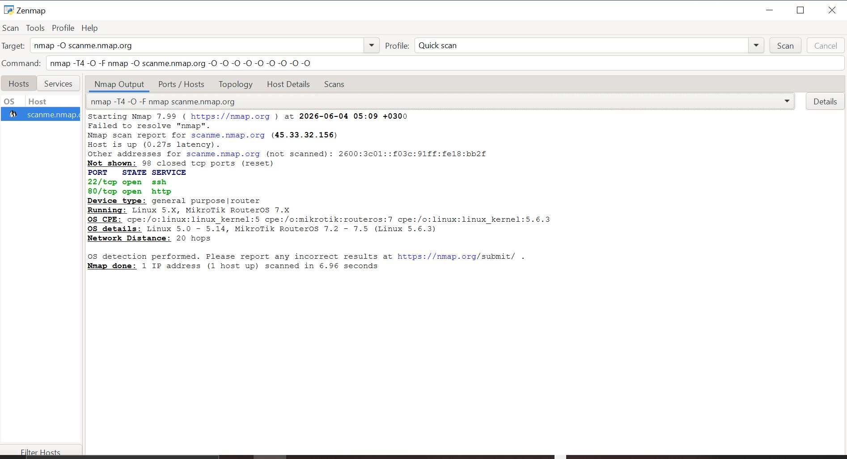

Narrowed down OS Scan
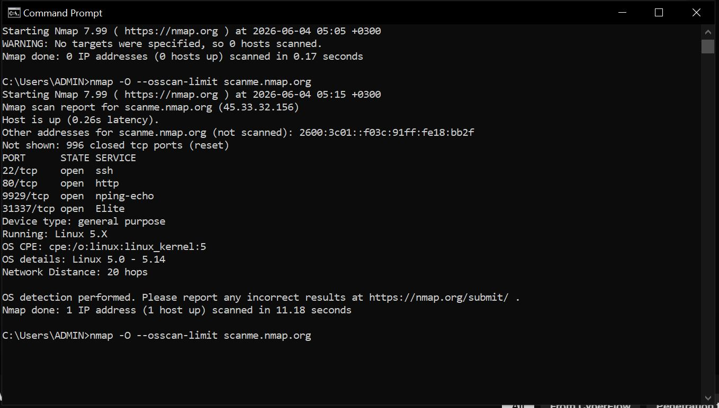

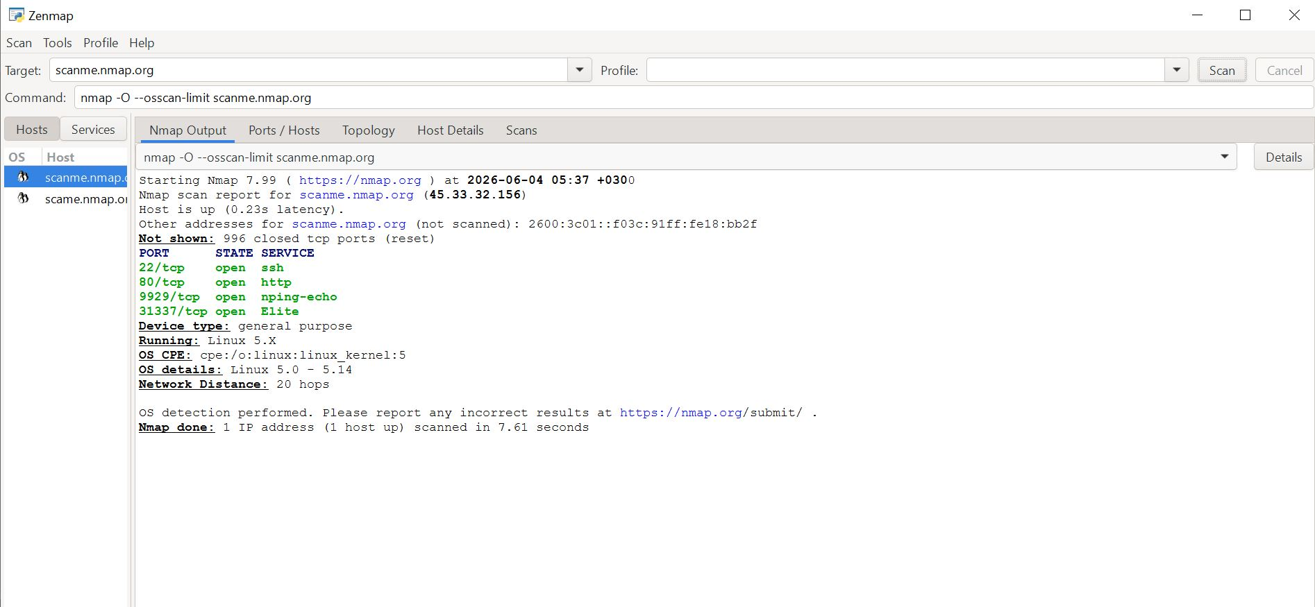

Aggressive Scans
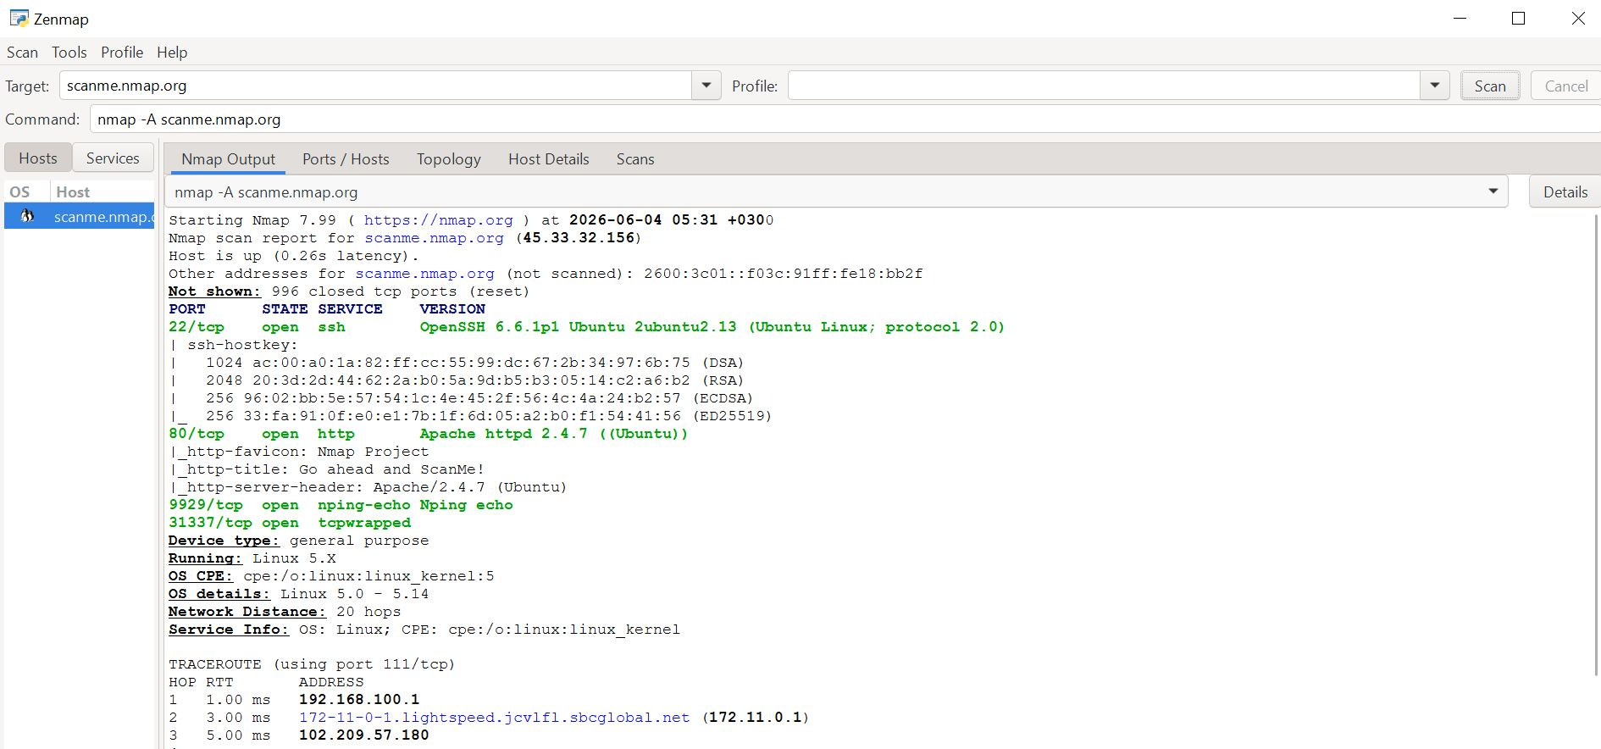

Aggressive scan on GUI
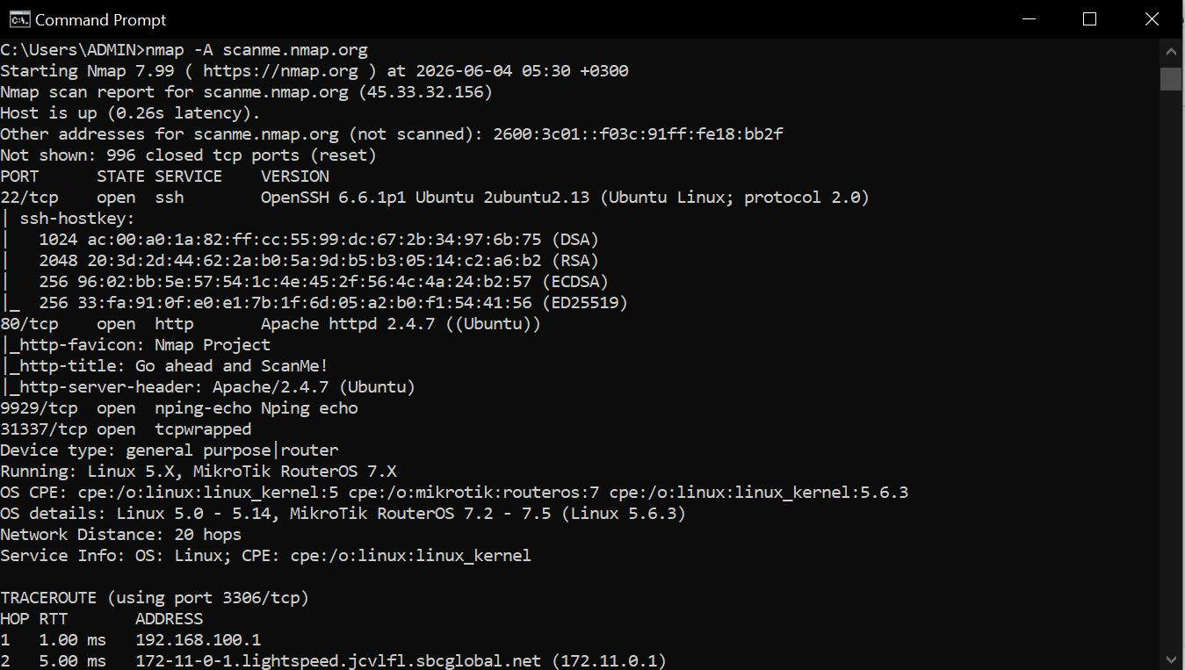

Host scanning
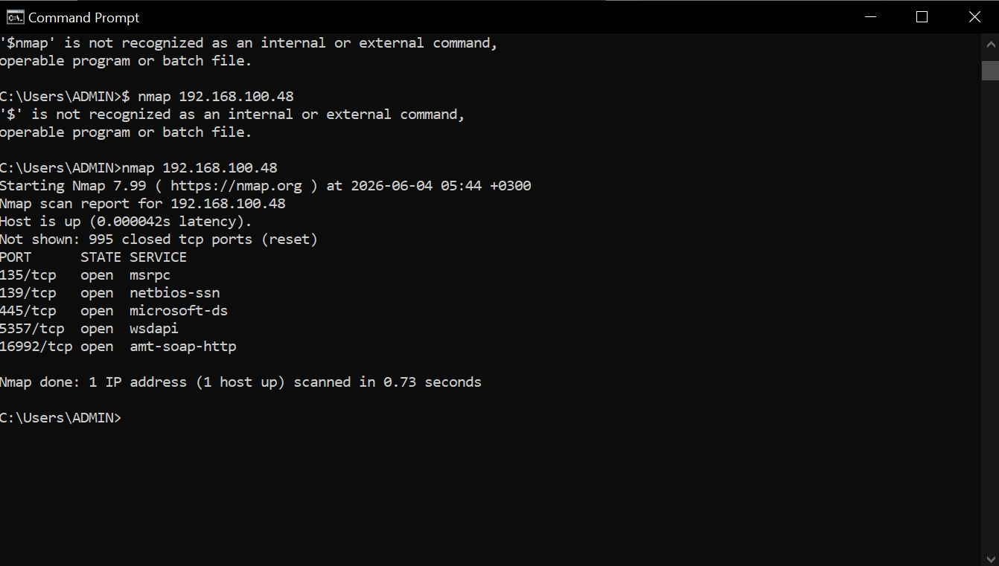
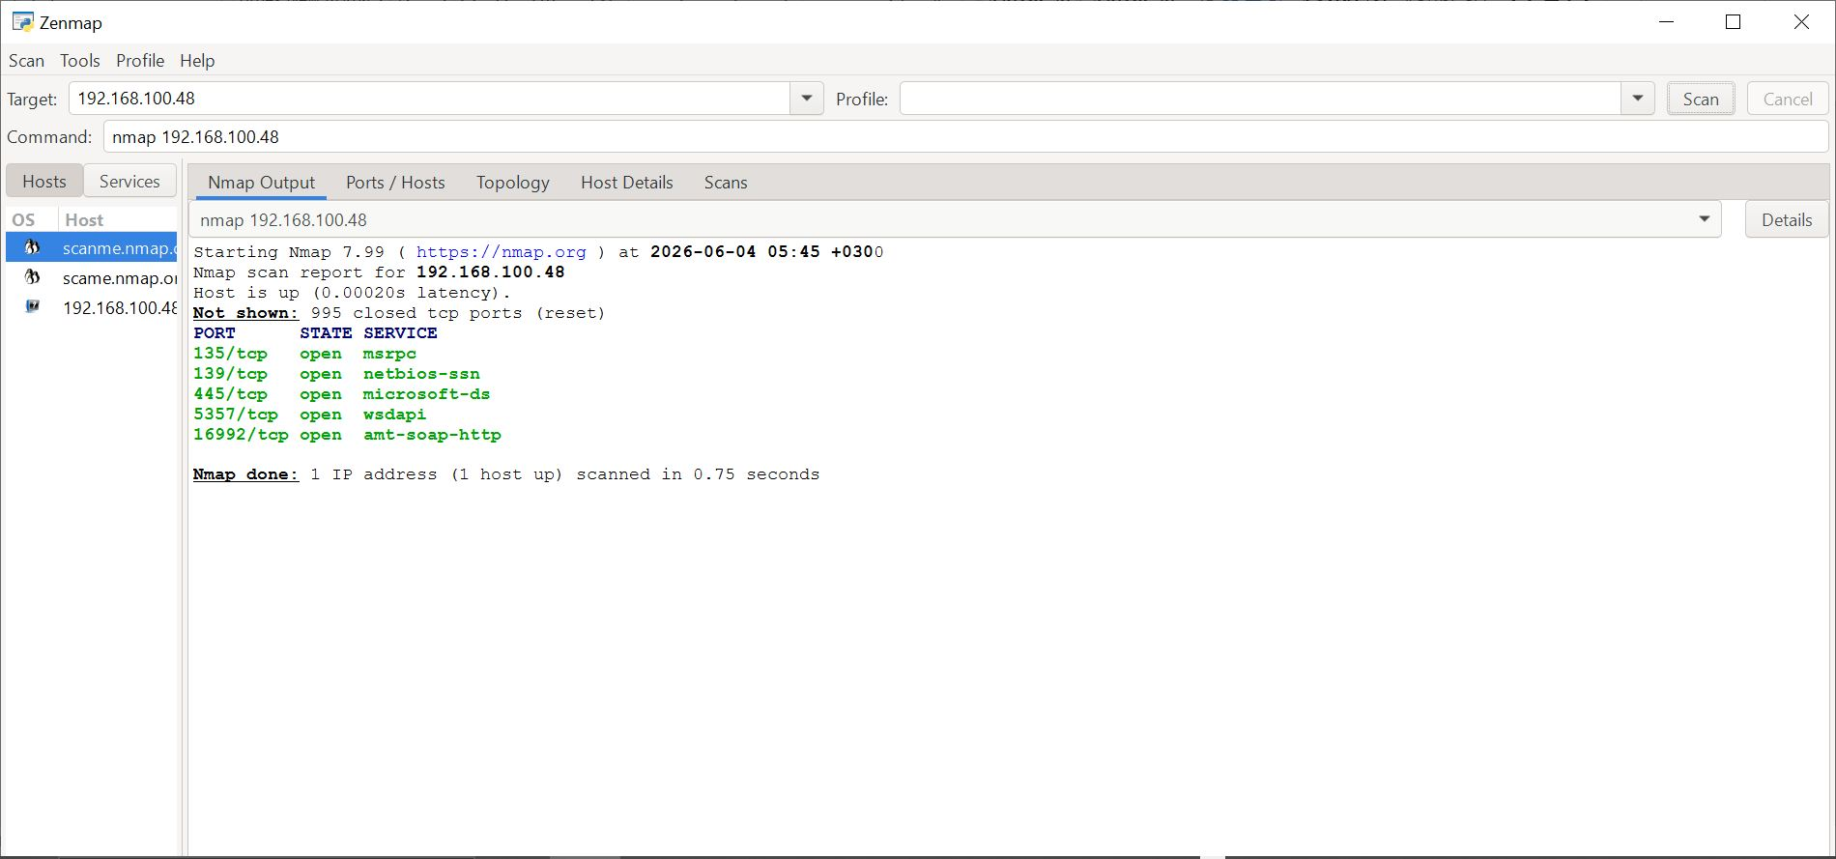

Scanning Multiple hosts
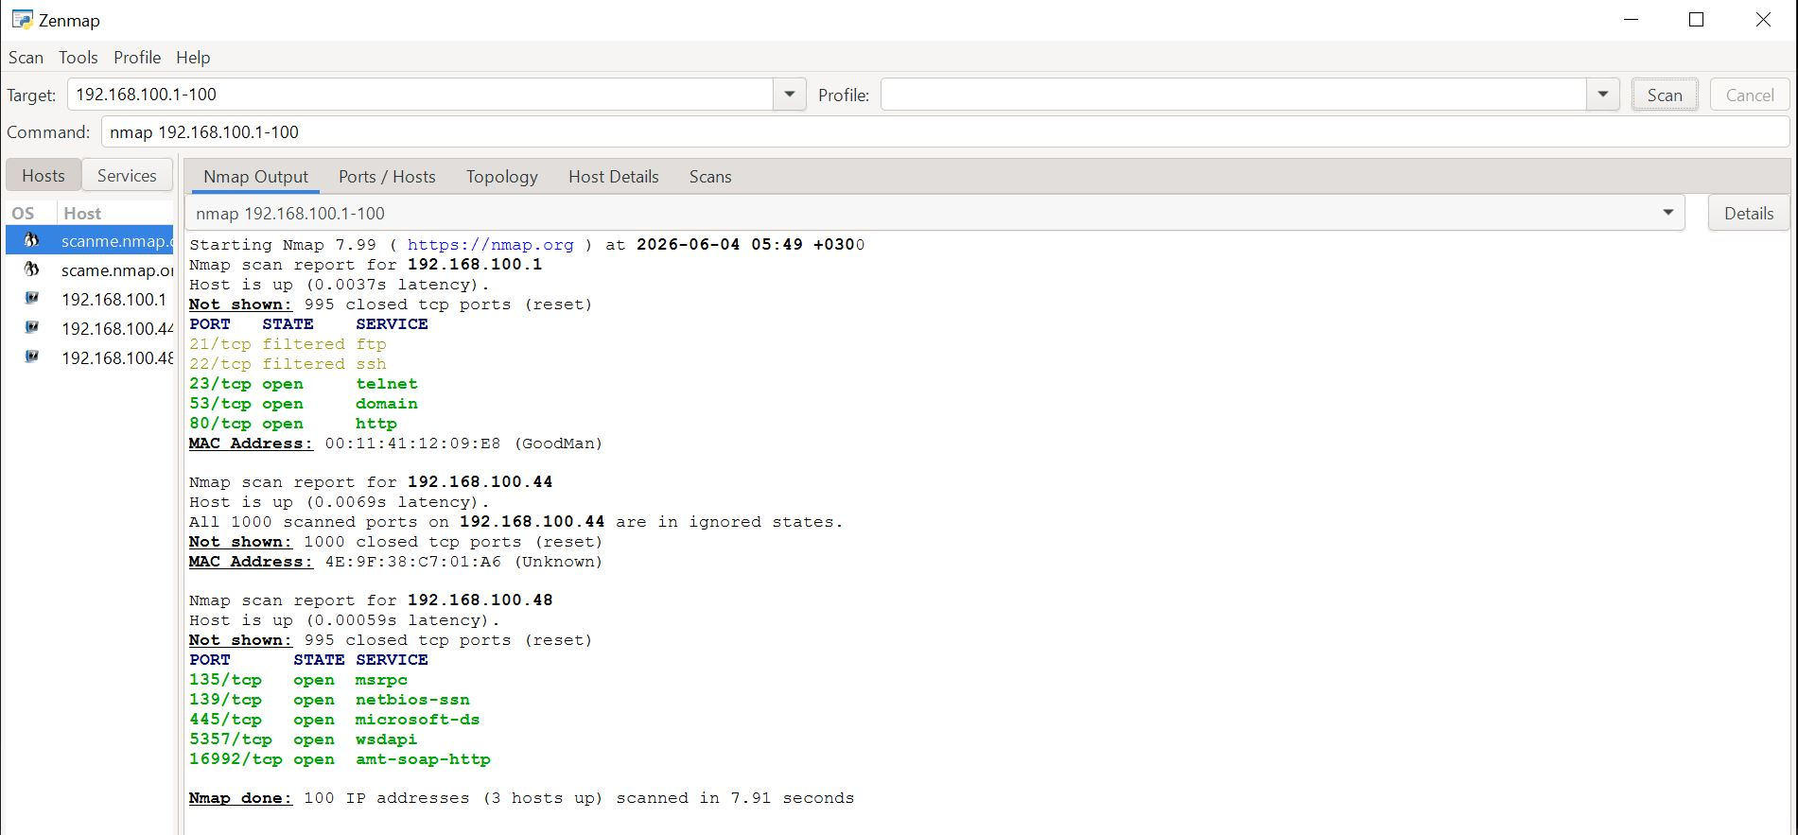

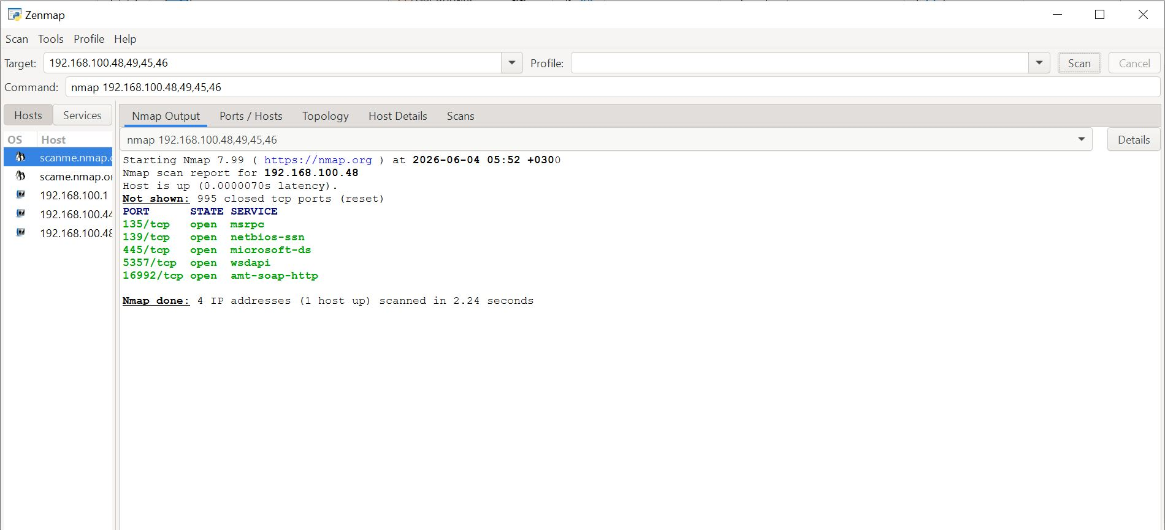

Scanning multiple hosts on CMD
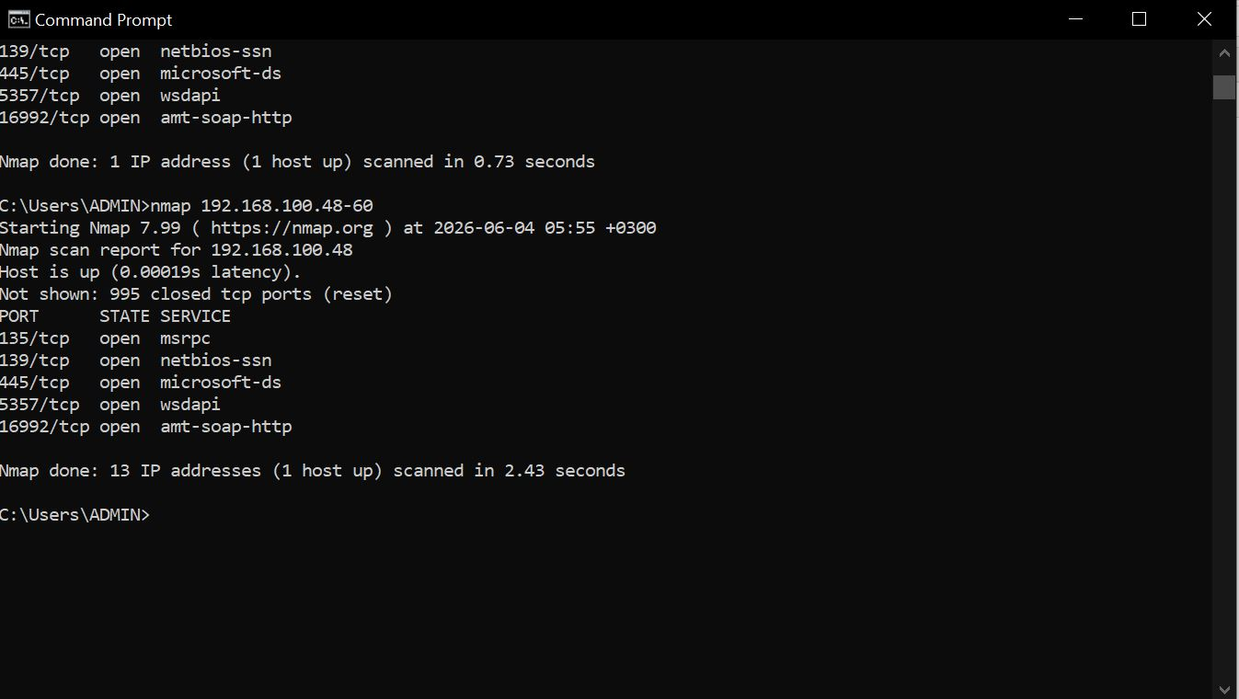

Port scanning
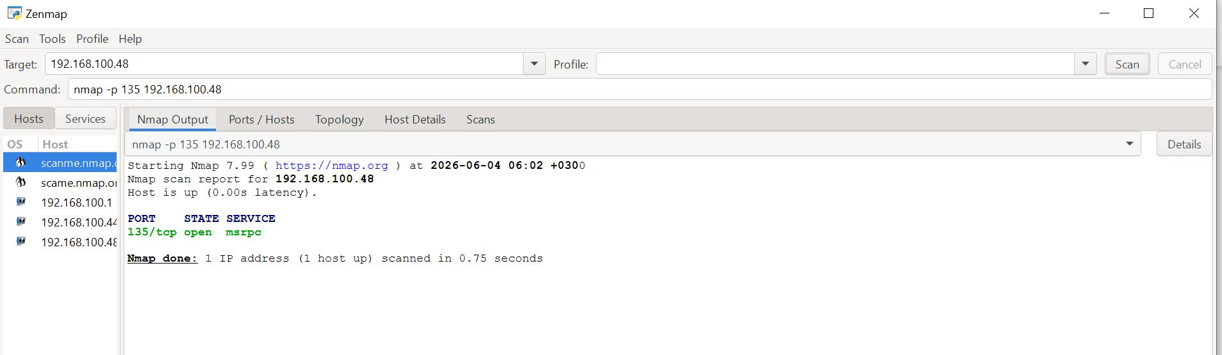

Port scan on CMD
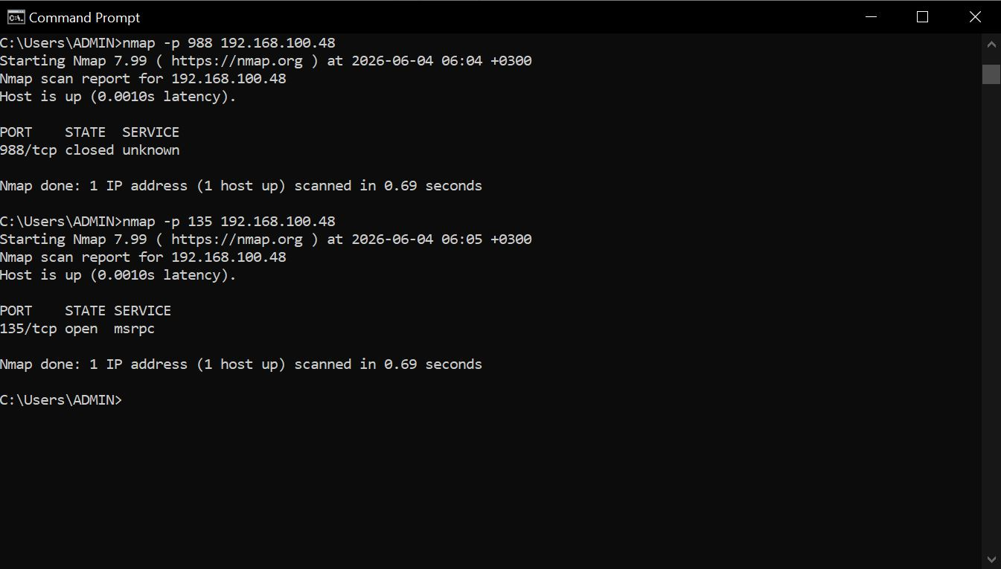

TCP port scan
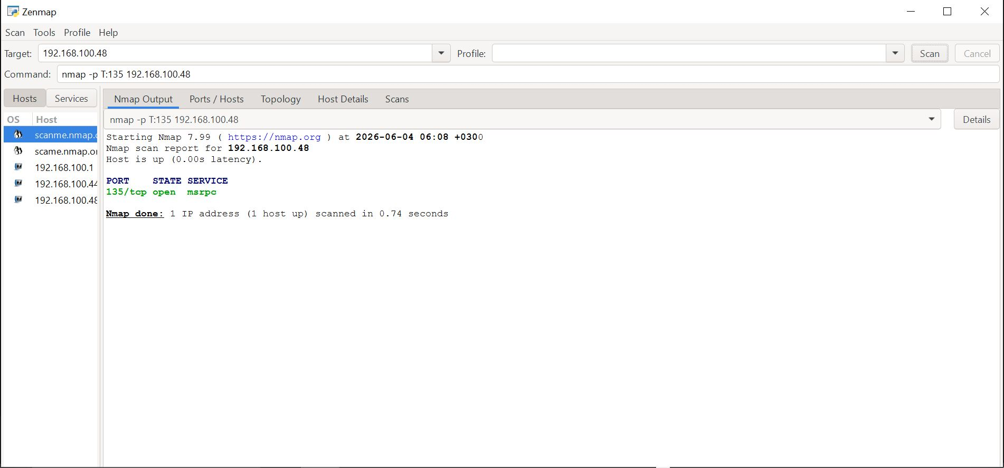

Scanning a range of TCP ports
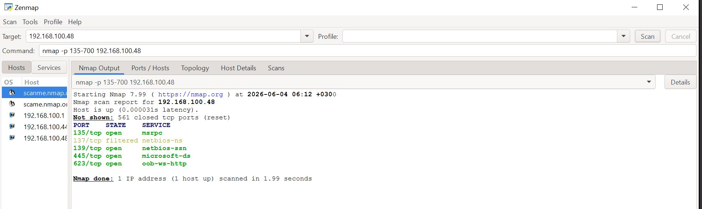

Scanning top 5 ports in my DNS
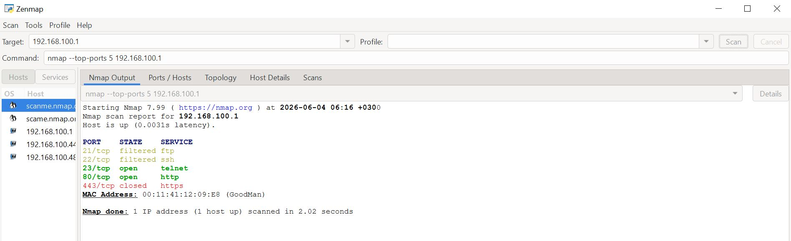

Week 4

Task 1

Sample institution- JPMorgan Chase

Domain info(chase.com)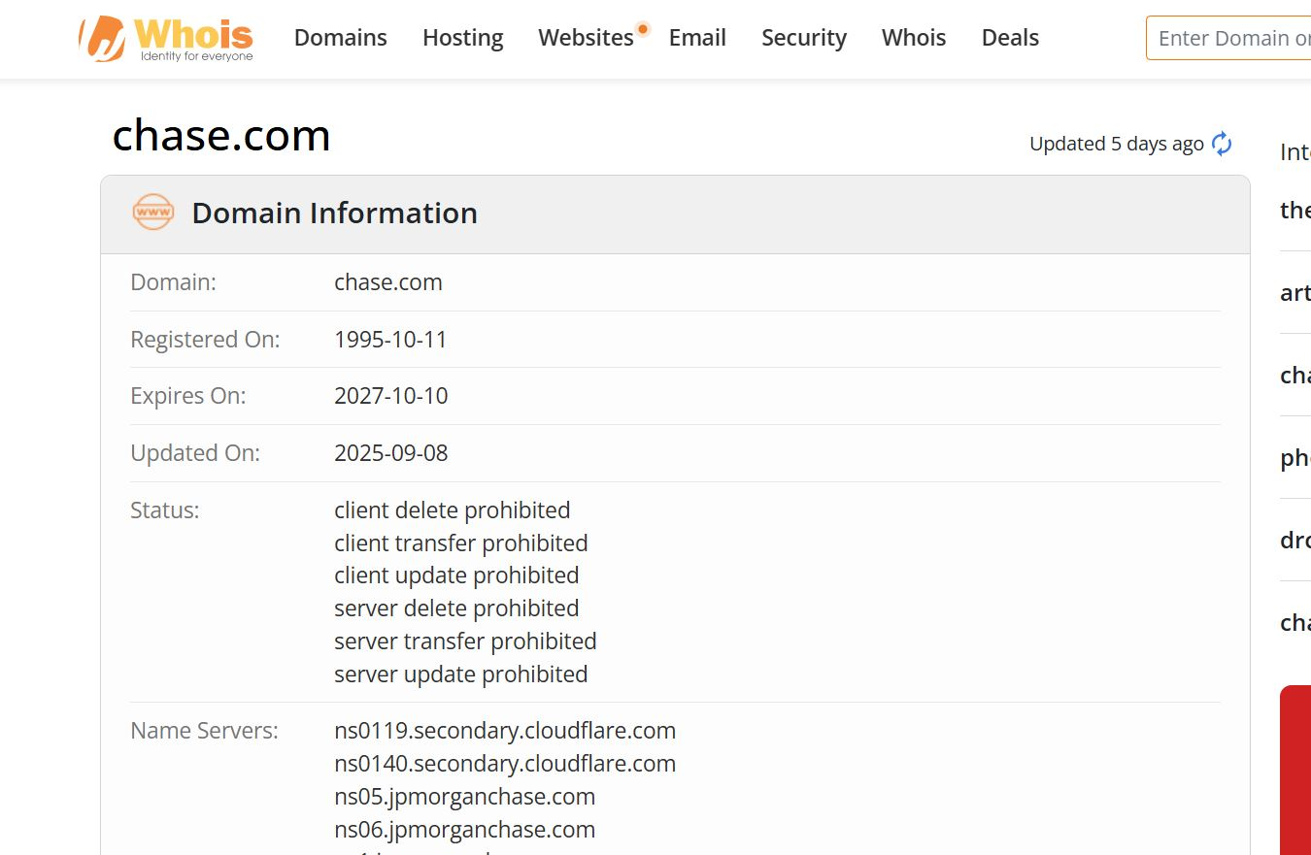

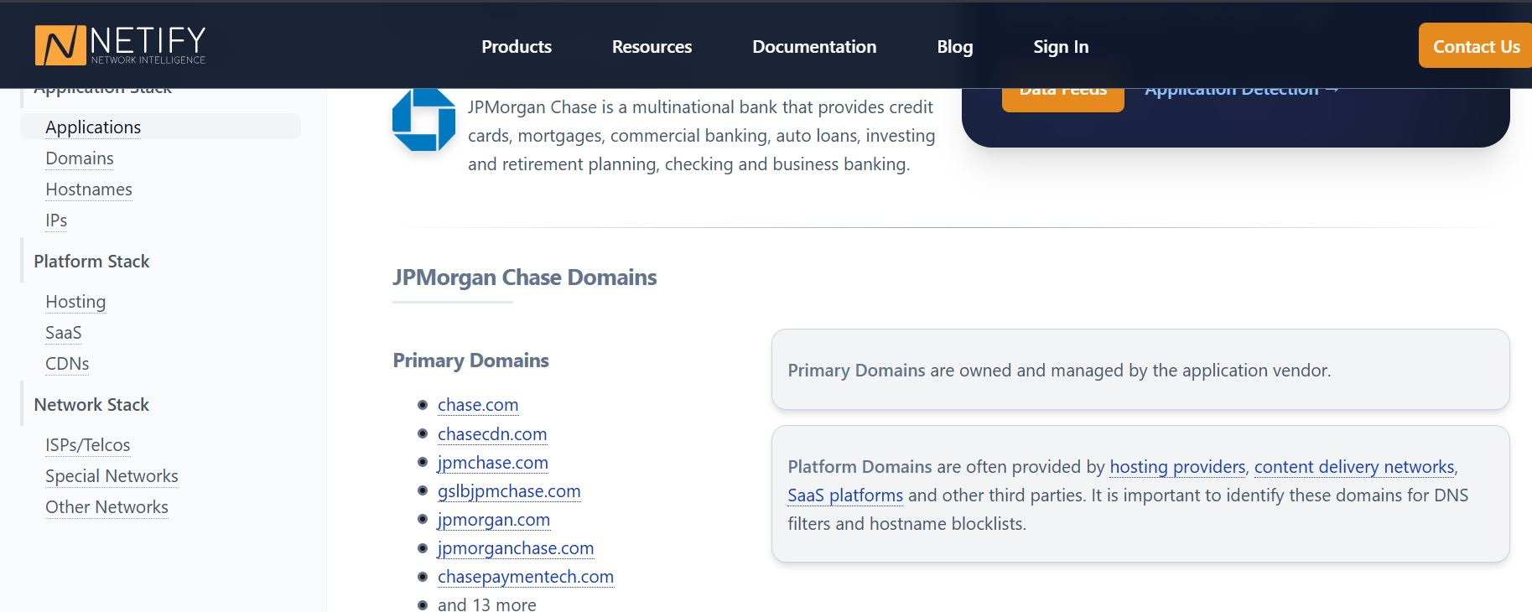
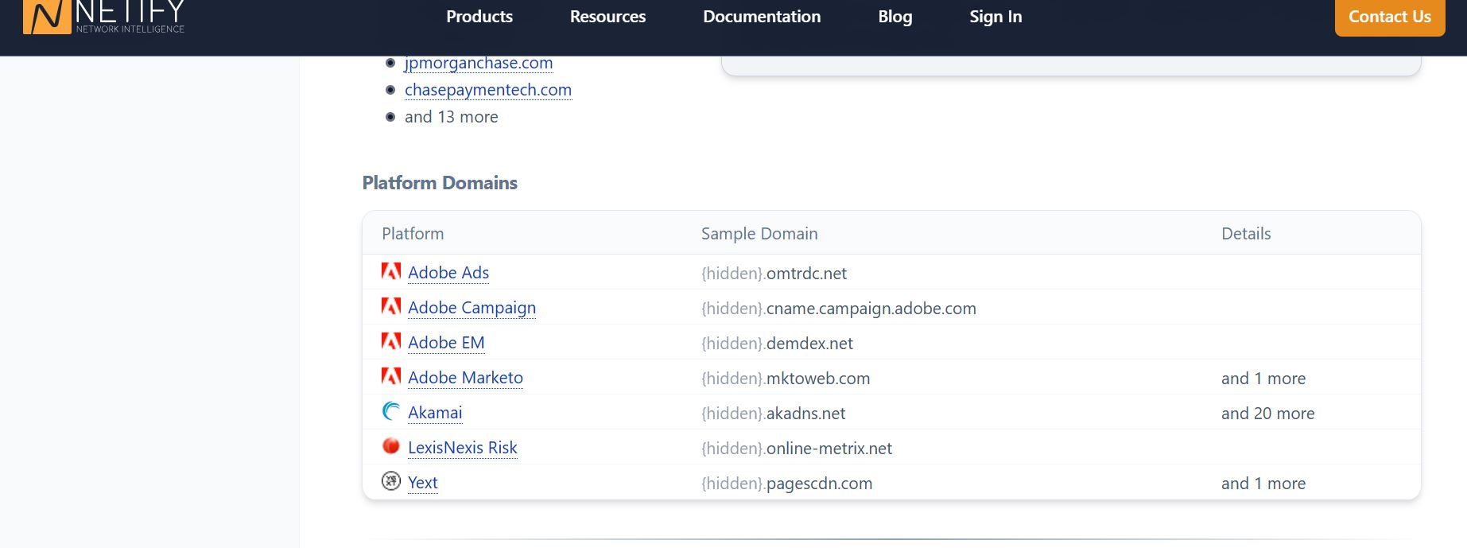
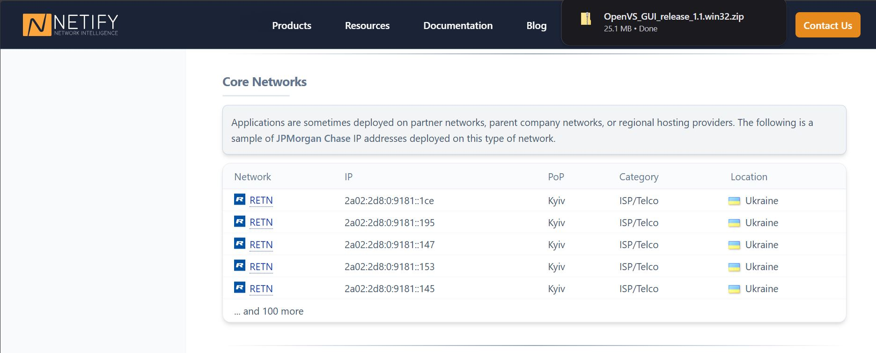

Domain registrar (chase.com)
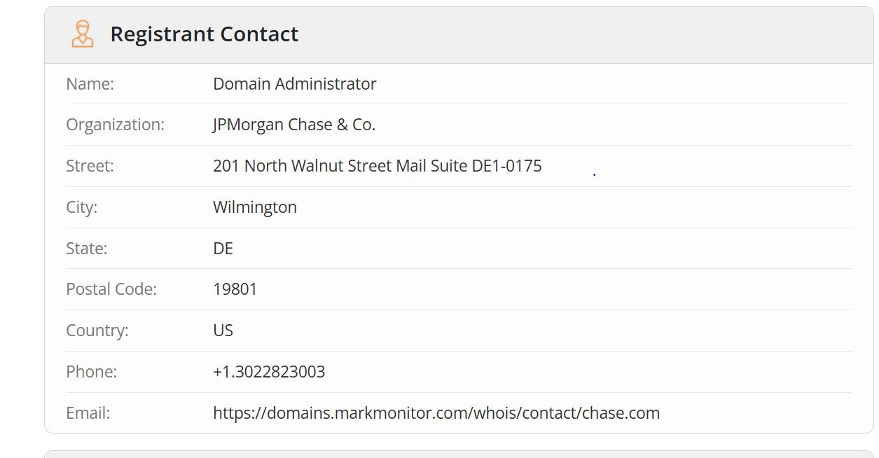

IP address (chase.com)
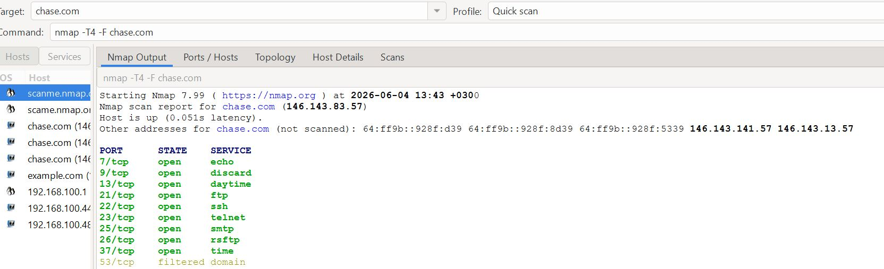

Email patterns
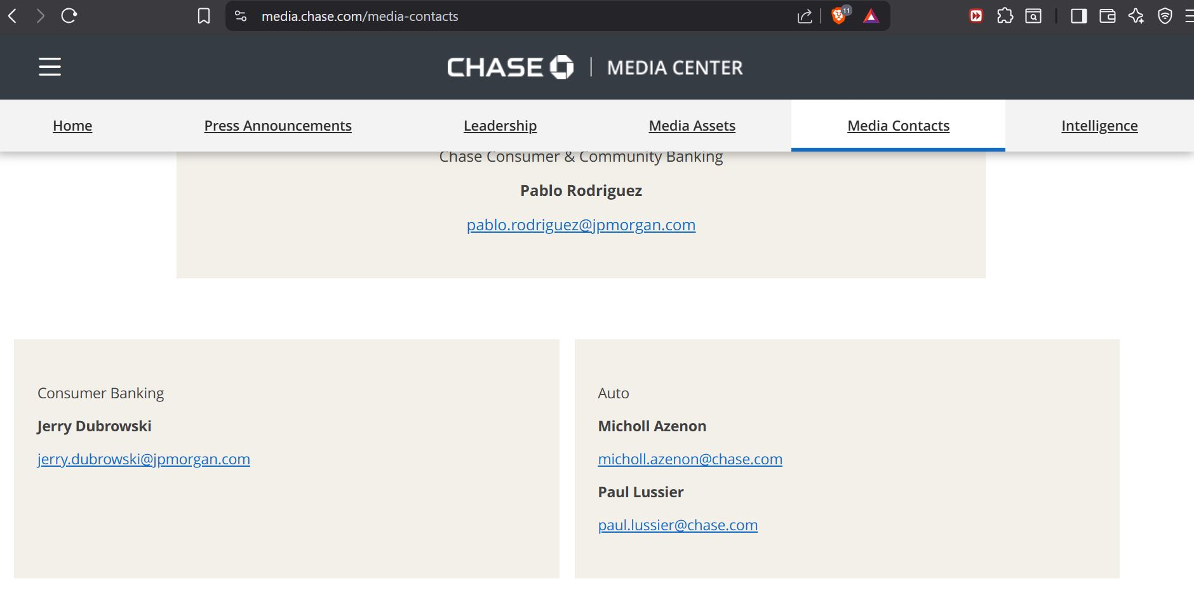

Having tried multiple scans on JP Morgan Chase website, I realized that I can’t really get much from it, with the tools I have on my computer.
Therefore, I switched to pentest-ground.com for the sake of completing my class work.

Task 2

Port scanning (chase.com)

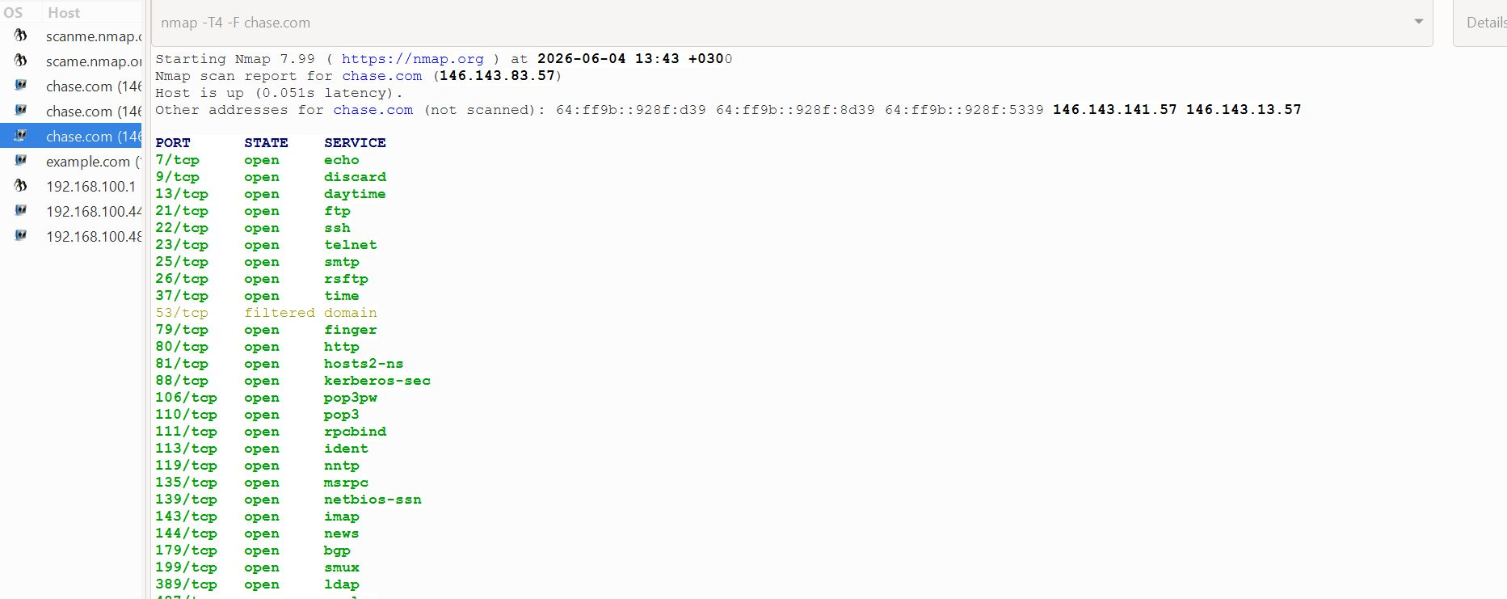

Detection of the running services (pentest-ground.com)

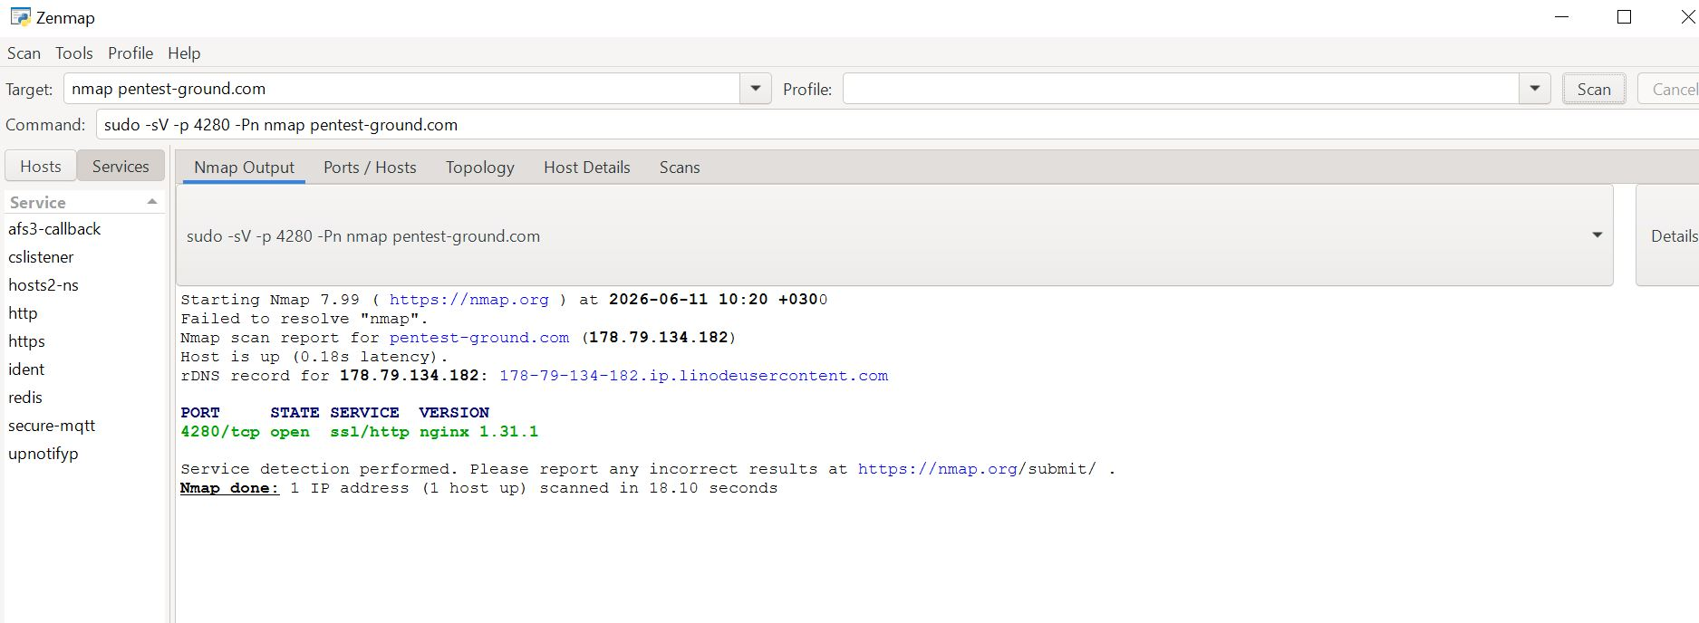

OS scan (pentest-ground.com)

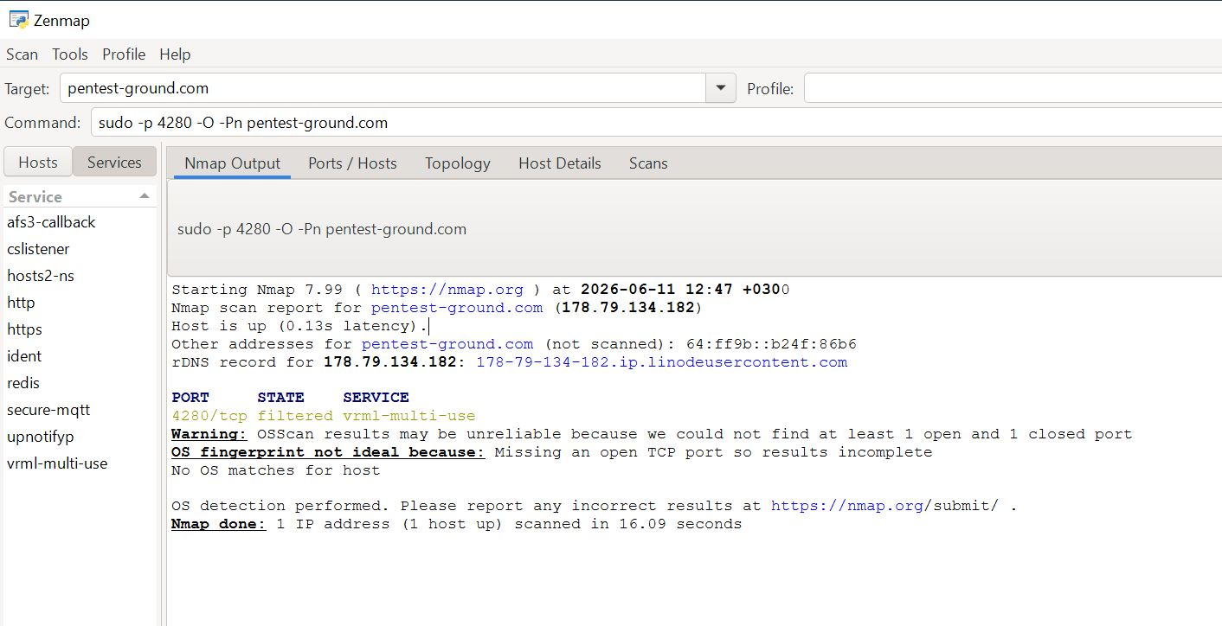

Web Technology Enumeration (pentest-ground.com)
